OPENGDC file format definition

Contents

Introduction 2
DNA Sequencing 4
Methylation Beta Value 8
Gene expression quantification 9
FPKM file 9
FPKM-UQ file 9
Counts file 10
RNA-SeqV2 12
Exon quantification 12
Splice junction (Spljxn) quantification 14
Rsem gene results & Rsem gene normalized results 15
miRNA-Seq 20
Copy Number Variation 23
Clinical and specimen (meta) data 25
Additional output files 27
Meta data dictionary file 27
Meta data information files 28
Experiment information files 28
Annotations files 28
Additional data file formats 29
CSV format 29
XML format 29
JSON format 30
GTF format 30

Introduction
Data sets
For the conversion of TCGA data files into the BED format, we actually take into account the following data sets, which include the genomic data that TCGA is currently providing publicly:
- DNA Sequencing (mutations)
- DNA Methylation
- Gene Expression Data (RNA-Seq, RNA-Seq V2 and miRNA-Seq)
- Copy Number Variation - SNP (Single Nucleotide Polymorphism) array-based data
- Clinical and specimen data (metadata)
We use the one-based (one-start or base-counted or fully-closed) genomic coordinate representation, as adopted in the TCGA data files.
We provide the user with all the data sets properly converted in BED format.
In particular, for each data set, the data are provided as follows:
- a .tsv experiment information file with the number of patients, the number of samples (tissues) and the number of aliquots available for the data set;
- a .bed file for each aliquot, containing the experimental data converted in standard BED format;
- a .meta file for each aliquot, with meta data including the patient clinical data;
- a header.schema file in xml format that describes the structure of the .bed files;
- a .txt metadata dictionary file that contains all metadata attributes with all the values that each attribute assumes in the metadata
Reference assembly
The genomic coordinates in all converted data sets refer to the human reference assembly GRCh37/hg19.
Data Granularity
We consider the aliquot as data granularity; it is the elementary unit of TCGA, which identifies a single experiment on a tissue. The aliquot is the unit of analysis for TCGA genomic data. Aliquots are the products shipped by the Biospecimen Core Resources to analysis centers. A Biospecimen Core Resource (BCR) is a TCGA center where samples are carefully catalogued, processed, quality-checked and stored along with participant clinical information.
More details are available at:
- https://wiki.nci.nih.gov/display/TCGA/Aliquot
- https://wiki.nci.nih.gov/display/TCGA/TCGA+barcode
- https://wiki.nci.nih.gov/display/TCGA/Biospecimen+Core+Resource

Tumor tags and tumor names

We use the following TCGA tumor tags, which correspond to the following tumor names:

ACC | Adrenocortical carcinoma
BLCA | Bladder Utothelial Carcinoma
BRCA | Breast Invasive Carcinoma
CESC | Cervical squamous cell carcinoma and endocervical adenocarcinoma
CHOL | Cholangiocarcinoma
COAD | Colon adenocarcinoma
DLBC | Lymphoid Neoplasm Diffuse Large B-cell Lymphoma
ESCA | Esophageal carcinoma
GBM | Glioblastoma multiforme
HNSC | Head and Neck squamous cell carcinoma
KICH | Kidney Chromophobe
KIRC | Kidney renal clear cell carcinoma
KIRP | Kidney renal papillary cell carcinoma
LAML | Acute Myeloid Leukemia
LGG | Brain Lower Grade Glioma
LIHC | Liver hepatocellular carcinoma
LUAD | Lung adenocarcinoma
LUSC | Lung squamous cell carcinoma
MESO | Mesothelioma
OV | Ovarian serous cystadenocarcinoma
PAAD | Pancreatic adenocarcinoma
PCPG | Pheochromocytoma and Paraganglioma
PRAD | Prostate adenocarcinoma
READ | Rectum adenocarcinoma
SARC | Sarcoma
SKCM | Skin Cutaneous Melanoma
STAD | Stomach adenocarcinoma
TGCT | Testicular Germ Cell Tumors
THCA | Thyroid carcinoma
THYM | Thymoma
UCEC | Uterine Corpus Endometrial Carcinoma
UCS | Uterine Carcinosarcoma
UVM | Uveal Melanoma

DNA Sequencing

This type of next generation sequencing (NGS) experiment discovers mutations by aligning DNA sequences derived from tumor samples to sequences derived from normal samples and a reference sequence. A MAF file identifies, for each sample, the discovered putative or validated mutations and categorizes those mutations (SNP, deletion, or insertion) as somatic (originating in the tissue) or germline (originating from the germline), as well as the annotation for those mutations.
More details are available at https://wiki.nci.nih.gov/display/TCGA/Mutation+Annotation+Format

Input: one .maf file for each tumor with all DNA-sequencing data is provided by TCGA (refer to Table 1 for field description)
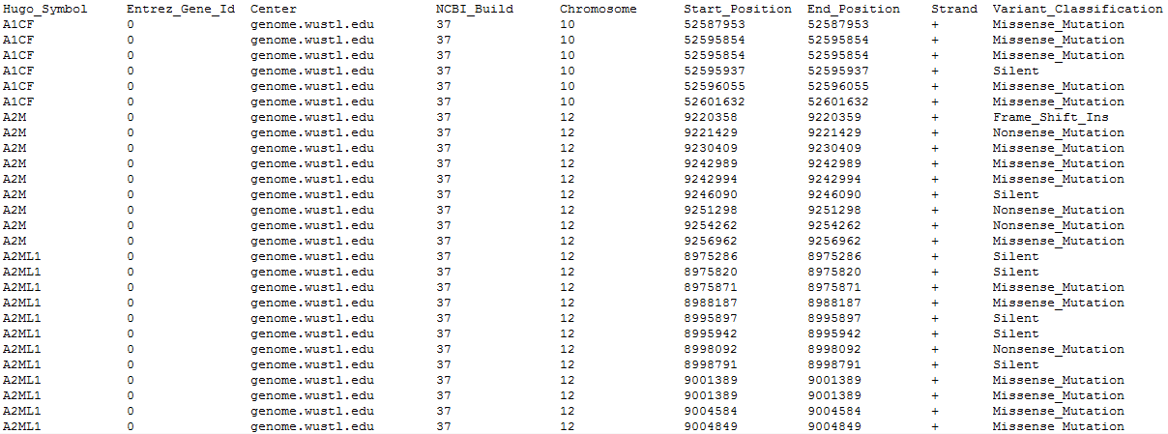

BED output format: Tab separated BED file, in which the DNA-seq .maf file is converted, with the following fields:
    - chrom (i.e., the name of the chromosome, e.g., chr3, chrY, chr2_random, retrieved from the 5. field of the TCGA maf file)
    - chromStart (i.e., the starting position of the feature in the chromosome or scaffold, e.g., 999, retrieved from the 6. field of the TCGA maf file)
    - chromEnd (i.e., the ending position of the feature in the chromosome or scaffold, e.g., 1000, retrieved from the 7. field of the TCGA maf file)
    - strand (i.e., it defines the strand, either '+' or '-'., retrieved from the 8. field of the TCGA maf file)
    - hugo_symbol (i.e., the symbol of the gene related to the reported variant, if it exists, e.g., “EGFR”, retrieved from the 1. field of the TCGA maf file)
    - entrez_gene_id (i.e., the Entrez gene ID of the gene related to the reported variant, if it exists, e.g., “1956”, retrieved from the 2. field of the TCGA maf file)
    - variant_classification (i.e., the classification of the reported variant, e.g., “Missense_Mutation”, retrieved from the 9. field of the TCGA maf file)
    - variant_type (i.e., the type of mutation, e.g., “INS”, retrieved from the 10. field of the TCGA maf file)
    - reference_allele (i.e., the plus strand reference allele at this position, e.g., “A”, retrieved from the 11. field of the TCGA maf file)
    - tumor_seq_allele1 (i.e., the tumor sequencing (discovery) allele 1, e.g., “C”, retrieved from the 12. field of the TCGA maf file)
    - tumor_seq_allele2 (i.e., the tumor sequencing (discovery) allele 2, e.g., “G”, retrieved from the 13. field of the TCGA maf file)
    - dbsnp_rs (i.e., the latest dbSNP rs ID, e.g., “rs12345”, retrieved from the 14. field of the TCGA maf file)
    - tumor_sample_barcode (i.e., the BCR aliquot barcode for the tumor sample, e.g., “TCGA-02-0021-01A-01D-0002-04”, retrieved from the 16. field of the TCGA maf file)
    - matched_norm_sample_barcode (i.e., the BCR aliquot barcode for the matched normal sample, e.g., “TCGA-02-0021-10A-01D-0002-04”, retrieved from the 17. field of the TCGA maf file)
    - match_norm_seq_allele1 (i.e., the Matched normal sequencing allele 1, e.g., “T”, retrieved from the 18. field of the TCGA maf file)
    - match_norm_seq_allele2 (i.e., the Matched normal sequencing allele 2, e.g., “ACGT”, retrieved from the 19. field of the TCGA maf file)
    - matched_norm_sample_uuid (i.e., the BCR aliquot UUID for matched normal, e.g., “567e8487-e29b-32d4-a716-446655443246”, retrieved from the 34. field of the TCGA maf file)
Furthermore:
- Definition of an xml schema that includes the selection of the subset of important attributes and their order by using the same name of the original TCGA attributes; if the attributes is imported as metadata, a special flag in the xml schema is used, e.g., metadata = ”yes”
- The selection is reported in Table 1, where the attributes are highlighted in yellow if imported as region attributes and in green if as metadata.

Notes about TCGA MAF format
- This format is not to be confused with the UCSC Multiple Alignment Format
- It concerns TCGA Level 2 data files
- It regards a tab-delimited file containing only somatic mutations (open access portion of the TCGA Data Portal)
- Mutations are discovered by aligning DNA sequences derived from tumor samples to sequences derived from normal samples and a reference sequence. A MAF file identifies, for each sample, the discovered putative or validated mutations and categorizes those mutations (SNP, deletion, or insertion) as somatic (originating in the tissue) as well as the annotation for those mutations.
- Somatic mutations:
  - Missense and nonsense
  - Splice site, defined as SNP within 2 bp of the splice junction
  - Silent mutations
  - Indels that overlap the coding region or splice site of a gene or the targeted region of a genetic element of interest
  - Frameshift mutations
  - Mutations in regulatory regions
- SNPs:
  - Any germline SNP with validation status "unknown" is included
  - SNPs already validated in dbSNP are not included since they are unlikely to be involved in cancer
- 34 columns are described in Table 1 and are required
- Column headers and values are case sensitive where specified
- Columns may allow null values (i.e. blank cells) and/or have enumerated values
Table 1: Selected fields of the TCGA MAF format
We highlight in yellow the fields which are converted to BED format, in green the fields that are imported as metadata

Id | Header | Description of Values | Example | Enumerated
1 | Hugo_Symbol | HUGO symbol for the gene (HUGO symbols are always in all caps). If no gene exists within 3kb enter "Unknown".  Source: http://genenames.org | EGFR | Set or Unknown
2 | Entrez_Gene_Id | Entrez gene ID (an integer). If no gene exists within 3kb enter "0".  Source: http://ncbi.nlm.nih.gov/sites/entrez?db=gene | 1956 | Set
3 | Center | Genome sequencing center reporting the variant. If multiple institutions report the same mutation separate list using semicolons. Non-GSC centers will be also supported if center name is an accepted center name. | hgsc.bcm.edu;genome.wustl.edu | Set
4 | NCBI_Build | Any TGCA accepted genome identifier. Can be string, integer or a float. | hg18, hg19, GRCh37, GRCh37-lite, 36, 36.1, 37, | Set and Enumerated
5 | Chromosome | Chromosome number without "chr" prefix that contains the gene. | X, Y, M, 1, 2, etc. | Set
6 | Start_Position | Lowest numeric position of the reported variant on the genomic reference sequence. Mutation start coordinate (1-based coordinate system). | 999 | Set
7 | End_Position | Highest numeric genomic position of the reported variant on the genomic reference sequence. Mutation end coordinate (inclusive, 1-based coordinate system). | 1000 | Set
8 | Strand | Genomic strand of the reported allele. Variants should always be reported on the positive genomic strand. (Currently, only the positive strand is an accepted value). | + | +
9 | Variant_Classification | Translational effect of variant allele. | Missense_Mutation | Frame_Shift_Del,Frame_Shift_Ins,In_Frame_Del,In_Frame_Ins,Missense_Mutation, Nonsense_Mutation, Silent,Splice_Site, Translation_Start_Site,Nonstop_Mutation, 3'UTR, 3'Flank, 5'UTR, 5'Flank, IGR¹ ,Intron,RNA,Targeted_Region
10 | Variant_Type | Type of mutation. TNP (tri-nucleotide polymorphism) is analogous to DNP but for 3 consecutive nucleotides. ONP (oligo-nucleotide polymorphism) is analogous to TNP but for consecutive runs of 4 or more. | INS | SNP, DNP, TNP, ONP, INS, DEL, or Consolidated²
11 | Reference_Allele | The plus strand reference allele at this position. Include the sequence deleted for a deletion, or "-" for an insertion. | A | A,C,G,T and/or -
12 | Tumor_Seq_Allele1 | Primary data genotype. Tumor sequencing (discovery) allele 1. " -" for a deletion represent a variant. "-" for an insertion represents wild-type allele. Novel inserted sequence for insertion should not include flanking reference bases. | C | A,C,G,T and/or -
13 | Tumor_Seq_Allele2 | Primary data genotype. Tumor sequencing (discovery) allele 2. " -" for a deletion represents a variant. "-" for an insertion represents wild-type allele. Novel inserted sequence for insertion should not include flanking reference bases. | G | A,C,G,T and/or -
14 | dbSNP_RS | Latest dbSNP rs ID (dbSNP_ID) or "novel" if there is no dbSNP record. source: ncbi.nlm.nih.gov/ projects/SNP/ | rs12345 | Set or "novel"
16 | Tumor_Sample_Barcode | BCR aliquot barcode for the tumor sample including the two additional fields indicating plate and well position. i.e. TCGA-SiteID-PatientID-SampleID-PortionID-PlateID-CenterID. The full TCGA Aliquot ID. | TCGA-02-0021-01A-01D-0002-04 | Set
17 | Matched_Norm_Sample_Barcode | BCR aliquot barcode for the matched normal sample including the two additional fields indicating plate and well position. i.e. TCGA-SiteID-PatientID-SampleID-PortionID-PlateID-CenterID. The full TCGA Aliquot ID; e.g. TCGA-02-0021-10A-01D-0002-04 (compare portion ID '10A' normal sample, to '01A' tumor sample). | TCGA-02-0021-10A-01D-0002-04 | Set
18 | Match_Norm_Seq_Allele1 | Primary data. Matched normal sequencing allele 1. "-" for deletions; novel inserted sequence for INS not including flanking reference bases. | T | A,C,G,T and/or -
19 | Match_Norm_Seq_Allele2 | Primary data. Matched normal sequencing allele 2. "-" for deletions; novel inserted sequence for INS not including flanking reference bases. | ACGT | A,C,G,T and/or -
28 | Sequence_Source | Molecular assay type used to produce the analytes used for sequencing. Allowed values are a subset of the SRA 1.5 library_strategy field values. This subset matches those used at CGHub. | WGS;WXS | Common TCGA values  WGS,WGA,WXS,RNA-Seq,miRNA-Seq,Bisulfite-Seq,VALIDATION,Other,Other allowed values (per SRA 1.5),ncRNA-Seq,WCS,CLONE,POOLCLONE,AMPLICON,CLONEEND,FINISHING,ChIP-Seq,MNase-Seq,DNase-Hypersensitivity,EST,FL-cDNA,CTS,MRE-Seq,MeDIP-Seq,MBD-Seq,Tn-Seq,FAIRE-seq,SELEX,RIP-Seq,ChIA-PET
32 | Sequencer | Instrument used to produce primary data. Separate multiple entries using semicolons. | Illumina GAIIx;SOLID | Illumina GAIIx  Illumina HiSeq  SOLID454  ABI 3730xl  Ion Torrent PGM  Ion TorrentProton  PacBio RS  Illumina MiSeq  Illumina HiSeq2500  454 GS FLX Titanium  AB SOLiD 4 System
33 | Tumor_Sample_UUID | BCR aliquot UUID for tumor sample | 550e8400-e29b-41d4-a716-446655440000
34 | Matched_Norm_Sample_UUID | BCR aliquot UUID for matched normal | 567e8487-e29b-32d4-a716-446655443246

Methylation Beta Value
Another wide-spread NGS experiment is large-scale analysis of DNA methylation, which consists in deep sequencing of bisulfite-treated DNA. DNA methylation can be defined as the covalent modification of cytosine bases at the C-5 position, generally within a CpG sequence context. If DNA methylation occurs in promoter regions, it is an epigenetic mark that represents the inactivity of the transcripts.
We consider both the HumanMethylation27 and HumanMethylation450 DNA methylation platforms.

Input:
One tab delimited file is provided by GDC for each aliquot, with the following fields:

- Composite Element REF (i.e., the composite element reference is used to record the location of what is aligned to (hg19 assembly))
- Beta_value (i.e., the beta-value is the ratio of the methylated probe intensity and the overall intensity (i.e., sum of methylated and un-methylated probe intensities))
- Chromosome (i.e., the chromosome where the methylation occurs)
- Start (i.e., the starting position of the probed CpG dinucleotide (a CpG island is where a cytosine nucleotide occurs next to a guanine nucleotide))
- End (i.e., the ending position of the probed CpG dinucleotide (a CpG island is where a cytosine nucleotide occurs next to a guanine nucleotide))
- Gene_Symbol (i.e., the symbol of the gene where the methylation occurs)
- Gene_Type
- Transcript_ID
- Position_to_TSS
- CGI_Coordinate
- Feature_Type
Each row in the input file refers to a single CpG island.

BED output format: Tab separated BED file, in which the DNA Methylation file is converted, with the following fields:

- chr (retrieved from the 3. field of the TCGA DNA methylation file, e.g., “16”)
- start (equal to Start, since methylation involve a single base and the used genomic coordinate system is 1-based)
- stop (equal to End, since methylation involve a single base and the used genomic coordinate system is 1-based)
- strand (retrieved from NCBI Entrez Gene database, based on the Entrez Gene ID retrieved from HUGO Gene Nomenclature Committee (HGNC) according to the human gene symbol provided in field 7, e.g., ‘+’)
- composite_element_ref (retrieved from the 1. field of the GDC Methylation file, e.g., “cg00000292”)
- beta_value (retrieved from the 2. field of the GDC Methylation file, e.g., 0.834741168636629)
- gene_symbol (retrieved from the first part splitted from ";" of the 6. field of the GDC Methylation file, e.g., “ATP2A1”)
- entrez_id (retrieved from HUGO Gene Nomenclature Committee (HGNC)2 according to the human gene symbol provided in field 7)
- gene_type (retrieved from the first part splitted from ";" of the 7. field of the GDC Methylation file, e.g., “protein_coding”)
- transcript_id (retrieved from the 8. field of the GDC Methylation file, e.g., “ENST00000262133.9;ENST00000544405.5;ENST00000567964.5”)
- position_to_tss (retrieved from the 9. field of the GDC Methylation file, e.g., “-221;-1420;222”)
- cgi_coordinate (retrieved from the 10. field of the GDC Methylation file, e.g.,” CGI:chr16:53434489-53435297”)
- feature_type (retrieved from the 11. field of the GDC Methylation file, e.g., “N_Shore”)
Note that:
- Missing values of attributes are labelled with the string “NA”

Gene expression quantification

Gene expression quantification data contain three files for each aliquot:
- FPKM (i.e., Fragments Per Kilobase of transcript per Million mapped reads)
- FPKM-UQ (i.e., Upper Quartile normalized FPKM values)
- counts (i.e., raw mapping counts)

More details are available at https://gdc.cancer.gov/about-data/data-harmonization-and-generation/genomic-data-harmonization/high-level-data-generation/rna-seq-quantification

FPKM file

Input:
One tab delimited file is provided by GDC for each aliquot, with the following fields:
- Gene_Ensembl
- FPKM (i.e., Fragments Per Kilobase of transcript per Million mapped reads)

FPKM-UQ file

Input:
One tab delimited file is provided by GDC for each aliquot, with the following fields:
- Gene_Ensembl
- UQ-FPKM (i.e., Upper Quartile normalized FPKM values)

Counts file

Input:
One tab delimited file is provided by GDC for each aliquot, with the following fields:
- Ensembl_id
- counts (i.e., the sum of fractions of reads (rounded off to the nearest integer - restricted by the RNA-seq validator) that mapped to collapsed transcripts representing a specific gene)

BED output format: Single tab separated BED file, with the following fields:
- chr (retrieved from Ensembl according to the ensembl_id , e.g., “chr4”)
- start (retrieved from Ensembl according to the ensembl_id , e.g., 109740692)
- stop retrieved from Ensembl according to the ensembl_id , e.g., 109802225)
- strand (retrieved from Ensembl according to the ensembl_id , e.g., ‘-’)
- ensemble_id (retrieved from the 1. field of one of the Gene expression quantification files, e.g., ENSG00000240423)
- symbol (retrieved from Ensembl according to the ensembl_id , e.g., “ABAT”)
- type (retrieved from Ensembl according to the ensembl_id , e.g., “gene”)
- htseq_count (retrieved from the 2. field of the counts file, e.g., 2032)
- fpkm_uq (retrieved from the 2. field of the FPKM-UQ file, e.g., 534727.393728)
- fpkm (retrieved from the 2. field of the FPKM file, e.g., 15.1205718295)

RNA-SeqV2

RNA-Seq Version 2 is similar to RNA-Seq in that it uses sequencing data to determine gene expression levels. RNA-Seq V2 experimental files contain data obtained with a different normalization technique than in RNA-Seq files, which is based on RSEM (RNA-Seq by Expectation Maximization) described in Bo L, Dewey CN. RSEM: accurate transcript quantification from RNA-Seq data with or without a reference genome. BMC Bioinformatics 2011;12: 323.

Six files are provided by TCGA for each aliquot:
- Exon quantification (i.e., the calculated expression signal of a particular composite exon of a gene)
- Splice junction (spljxn) quantification (i.e., the calculated expression signal of a particular composite splice junction of a gene)
- Rsem gene results (i.e., the raw expression signal for the expression of a gene)
- Rsem gene normalized results (i.e., the normalized results for the expression of a gene)
- Rsem isoform results (i.e., the raw expression signal of individual isoforms (transcripts))
- Rsem isoform normalized results (i.e., the normalized expression signal of individual isoforms (transcripts))

More details are available at https://wiki.nci.nih.gov/display/TCGA/RNASeq+Version+2

Exon quantification

Input:
One tab delimited file is provided by TCGA for each aliquot, with the following fields:
- Exon (i.e., the exon whose expression is quantified)
- Raw_counts (i.e., the sum of fractions of reads that mapped to an exon)
- Median_length_normalized (i.e., the average coverage over the exon, defined as the sum of the coverage depths at each base in an exon divided by the length of the exon)
- RPKM (i.e., Reads Per Kilobase per Million mapped reads, see Mortazavi et al., Nat Methods 2008, for the detailed explanation)

Each row in the input file refers to a single exon.

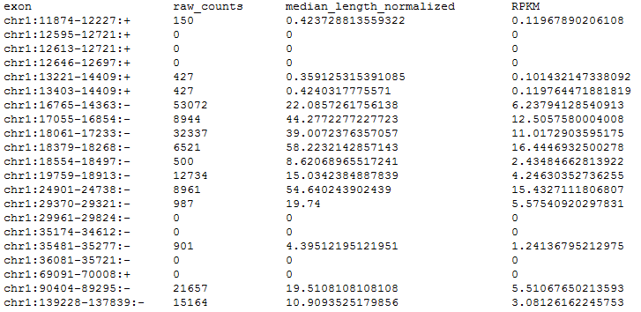

BED output format: Tab separated BED file, in which the RNA-seq V2 Exon quantification file is converted, with the following fields:
- chrom (retrieved from the 1. field of the TCGA RNA-Seq V2 file, part just before the first “:”, e.g., “chr1”)
- chromStart (retrieved from the 1. field of the TCGA RNA-Seq V2 file, part just after the first “:”, e.g., 11874)
- chromEnd (retrieved from the 1. field of the TCGA RNA-Seq V2 file, part just before the second “:”, e.g., 12227)
- strand (retrieved from the 1. field of the TCGA RNA-Seq V2 file, part just after the second “:”, e.g., ‘+’)
- raw_counts (retrieved from the 2. field of the TCGA RNA-Seq V2 file, e.g., 150)
- median _length_normalized (retrieved from the 3. field of the TCGA RNA-Seq V2 file, e.g., 0.423728813559322)
- rpkm (retrieved from the 4. field of the TCGA RNA-Seq V2 file, e.g., 0.11967890206108)

Splice junction (Spljxn) quantification

Input:
One tab delimited file is provided by TCGA for each aliquot, with the following fields:
- Junction (i.e., the coordinates of an exon-exon junction)
- Raw_counts (i.e., the sum of fractions of reads that mapped to exon-exon junctions)

Each row in the input file refers to a single splice junction.

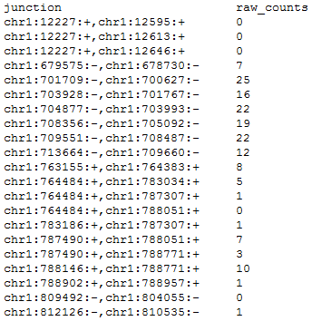

BED output format: Tab separated BED file, in which the RNA-seq V2 Spljxn quantification file is converted, with the following fields:
- chrom (retrieved from the 1. field of the TCGA RNA-Seq V2 file, part just before the first “:”, e.g., “chr1”)
- chromStart (retrieved from the 1. field of the TCGA RNA-Seq V2 file, part just after the first “:”, e.g., 12227)
- chromEnd (retrieved from the 1. field of the TCGA RNA-Seq file V2, part just before the third “:”, e.g., 12595)
- strand (retrieved from the 1. field of the TCGA RNA-Seq V2 file, part just after the second “:”,, e.g., ‘+’)
- raw_counts (retrieved from the 2. field of the TCGA RNA-Seq V2 file, e.g., 0)
- inner_left = chromStart + 1
- inner_right = chromEnd - 1

Rsem gene results & Rsem gene normalized results

Input:
One tab delimited file is provided by TCGA for each aliquot, with the following fields:
- Gene_id (i.e., the Entrez gene ID of the gene whose expression is quantified)
- Raw_count^{(*)} (i.e., see “Important remarks” on page 20)
- Scaled_estimate^{(*)} (i.e., see “Important remarks” on page 20)
- Transcript_id (i.e., the UCSC database ID of the transcript)

Each row in the input file refers to a single gene.

Input normalized:
Another tab delimited file is provided by TCGA for each aliquot, with the following fields:
- Gene_id (i.e., the Entrez gene ID of the gene whose expression is quantified)
- Normalized_count (i.e., RSEM expression estimates normalized to set the upper quartile count at 1000 for gene level estimates, by dividing all "raw_count" values by the 75th percentile of the raw counts (after removing zeros) and multiply that by 1000)
Each row in the input file refers to a single gene.

We merge the two original TCGA files in one single BED file by adding the normalized_count field after the other fields.
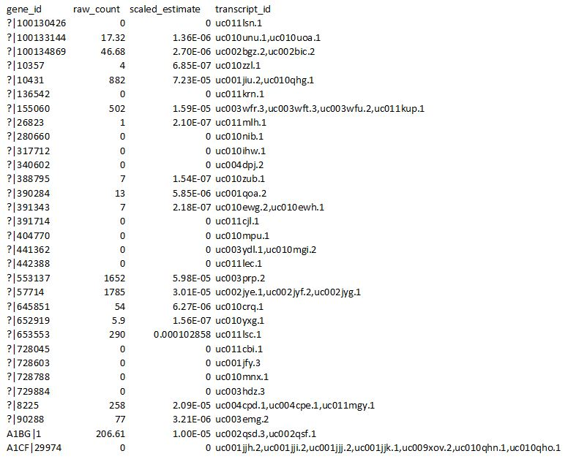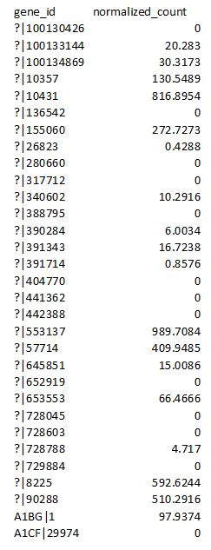

BED output format: Tab separated BED file, in which the RNA-seq V2 Gene file is converted, with the following fields:
- chrom (retrieved from NCBI Entrez Gene database, according to the entrez gene id provided in field 6, e.g., “chr4”)
- chromStart (retrieved from NCBI Entrez Gene databaseError: Reference source not found, according to the entrez gene id provided in field 6, e.g., 109740692)
- chromEnd (retrieved from NCBI Entrez Gene databaseError: Reference source not found, according to the entrez gene id provided in field 6, e.g., 109802225)
- strand (retrieved from NCBI Entrez Gene databaseError: Reference source not found, according to the entrez gene id provided in field 6, e.g., ‘-’)
- gene_symbol (retrieved from the 1. field of the TCGA RNA-Seq V2 gene results file, part just before “|”; it represents the symbol of the quantified gene, e.g., “CFI”)
- entrez_gene_id (retrieved from the 1. field of the TCGA RNA-Seq V2 gene results file, part just after “|”; it represents the Entrez gene ID of the quantified gene, e.g., “3426”)
- raw_count^{(*)} (retrieved from the 2. field of the TCGA RNA-Seq V2 gene results file, e.g., 131.00)
- scaled_estimate^{(*)} (retrieved from the 3. field of the TCGA RNA-Seq V2 gene results file, e.g., 2.18150649130347e-06)
- transcript_id (retrieved from the 4. field of the TCGA RNA-Seq V2 gene results file, this field may include multiple transcript ids delimitated by comma “,”, e.g., uc003hzq.2,uc003hzr.3,uc003hzs.3,uc011cft.1)
- normalized_count (retrieved from the 2. field of the TCGA RNA-Seq V2 gene result normalized file, e.g., 45.1503)

Rsem isoform results & Rsem isoform normalized results
Input:
One tab delimited file is provided by TCGA for each aliquot, with the following fields:
- Isoform_id (i.e., the UCSC database ID of the isoform whose expression is quantified)
- Raw_count^{(*)} (i.e., see “Important remarks” on page 20)
- Scaled_estimate^{(*)} (i.e., see “Important remarks” on page 20)

Each row in the input file refers to a single isoform.

Input normalized:
Another tab delimited file is provided by TCGA for each aliquot, with the following fields:
- Isoform_id (i.e., the UCSC database ID of the isoform whose expression is quantified)
- Normalized_count (i.e., RSEM expression estimates normalized to set the upper quartile count at 300 for isoform level estimates, by dividing all "raw_count" values by the 75th percentile of the raw counts (after removing zeros) and multiply that by 1000)

Each row in the input file refers to a single isoform.

We merge the two original TCGA files in one single BED file by adding the normalized_count field after the other fields.
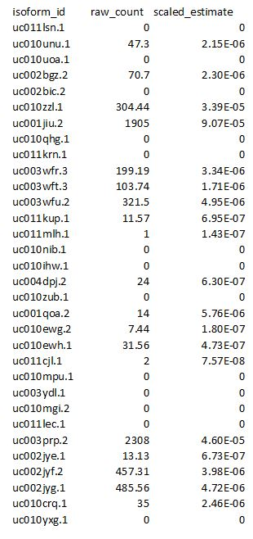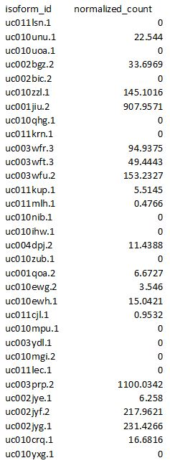
BED output format: Tab separated BED file, in which the RNA-seq V2 isoform file is converted, with the following fields:
- chrom (retrieved from NCBI Entrez Gene database, according to the entrez gene id retrieved from UCSC database based on the UCSC isoforms_id provided in 1. field of the TCGA RNA-Seq isoform results V2 file, e.g., “chr17”)
- chromStart (retrieved from NCBI Entrez Gene databaseError: Reference source not found, according to the entrez gene id retrieved from UCSC database⁸ based on the UCSC isoforms_id provided in 1. field of the TCGA RNA-Seq isoform results V2 file , e.g., 8310238)
- chromEnd (retrieved from NCBI Entrez Gene databaseError: Reference source not found, according to the entrez gene id retrieved from UCSC database⁸ based on the UCSC isoforms_id provided in 1. field of the TCGA RNA-Seq isoform results V2 file, e.g., 8322516)
- strand (retrieved from NCBI Entrez Gene databaseError: Reference source not found, according to the entrez gene id retrieved from UCSC database⁸ based on the UCSC isoforms_id provided in 1. field of the TCGA RNA-Seq isoform results V2 file e.g., ‘+’)
- gene_symbol (retrieved from NCBI Entrez Gene databaseError: Reference source not found, according to the entrez gene id retrieved from UCSC database⁸ based on the UCSC isoforms_id provided in 1. field of the TCGA RNA-Seq isoform results V2 file, e.g., “ARHGEF15”)
- entrez_gene_id (retrieved from NCBI Entrez Gene databaseError: Reference source not found, according to the entrez gene id retrieved from UCSC database⁸ based on the UCSC isoforms_id provided in 1. field of the TCGA RNA-Seq isoform results V2 file, e.g., “22899”)
- transcript_id (retrieved from the 1. field “isoform_id” of the TCGA RNA-Seq V2 isoform results file, e.g., uc002glb.1)
- raw_count^{(*)} (retrieved from the 2. field of the TCGA RNA-Seq V2 isoform results file, e.g., 8.31)
- scaled_estimate^{(*)} (retrieved from the 3. field of the TCGA RNA-Seq isoform results V2 file, e.g., 1.42848669335672e-07)
- normalized_count (retrieved from the 2. field of the TCGA RNA-Seq V2 isoform result normalized file, e.g., 3.2186)

^{(*)} Important remarks:
[http://seqanswers.com/forums/showthread.php?t=42911]
[https://wiki.nci.nih.gov/display/TCGA/RNASeq+Version+2]
Raw count represents the (estimated) number of reads that aligned to a transcript (in the case of Rsem genes or Rsem isoforms). This value is not an integer because RSEM only reports a guess of how many ambiguously mapping reads belong to a transcript/gene. This number is what the TCGA slightly misleadingly calls raw counts.
The scaled estimate value is the estimated frequency of the gene/transcript amongst the total number of transcripts that were sequenced. Newer versions of RSEM call this value (multiplied by 1e6) TPM - Transcripts Per Million. It’s closely related to FPKM, as explained on the RSEM website (http://deweylab.biostat.wisc.edu/rsem/rsem-calculate-expression.html#output). The important point is that TPM, like FPKM, is independent of transcript length, whereas "raw" counts are not.
The *.normalized_results files just contain a scaled version of the raw_count column. The values are divided by the 75-percentile and multiplied by 1000. This should make the values a bit more comparable between experiments.
The files use Universally Unique Identifier (UUID) as patient id and as file name, which is a randomly-generated, 32-digit hexadecimal value. There is a repository for converting a UUID to a conventional TCGA patient’s id (TCGA barcode) available at the RNA-Seq V2 meta data files.

miRNA-Seq

miRNA-Seq data are derived from the sequencing of micro RNAs (miRNA); they contain information about both nucleotide sequence and expression.
More details are available at https://wiki.nci.nih.gov/display/TCGA/miRNASeq

Two files are provided by TCGA for each aliquot:
- miRNA quantification (i.e., the calculated expression for all reads aligning to a particular miRNA)
- Isoform quantification (i.e., the calculated expression for each individual miRNA sequence isoform observed)

miRNA quantification
Input:
One tab delimited file is provided by TCGA for each aliquot, with the following fields:
- miRNA_ID (i.e., a valid miRBase ID (http://www.mirbase.org/))
- read_count (i.e., the sum of fractions of reads that mapped to a miRNA)
- reads_per_million_miRNA_mapped (i.e., millions of reads that mapped to a miRNA)
- cross-mapped (i.e., cross-mapped to other miRNA forms (Y or N))

Each row in the input file refers to a single miRNA.

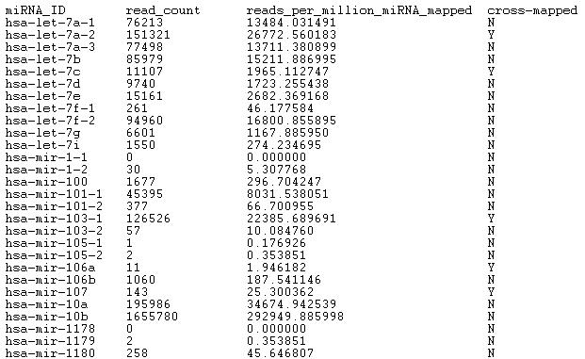

BED output format: Tab separated BED file, in which the miRNA-seq Mirna quantification file is converted, with the following fields:
- chrom (retrieved from miRBase database, according to the miRNA id provided in field 5, e.g., “chr9”)
- chromStart (retrieved from miRBase databaseError: Reference source not found, according to the miRNA id provided in field 5, e.g., 94175957)
- chromEnd (retrieved from miRBase databaseError: Reference source not found, according to the miRNA id provided in field 5, e.g., 94176036)
- strand (retrieved from miRBase databaseError: Reference source not found, according to the miRNA id provided in field 5, e.g., ‘+’)
- mirna_id (retrieved from the 1. field of the TCGA miRNA-Seq file, e.g., “hsa-let-7a-1”)
- read_count (retrieved from the 2. field of the TCGA miRNA -Seq file, e.g., 29726)
- reads_per_million_miRNA_mapped (retrieved from the 3. field of the TCGA miRNA -Seq file, e.g., 12429.699816)
- cross-mapped (retrieved from the 4. field of the TCGA miRNA -Seq file, e.g., ‘N’)
- entrez_gene_id (retrieved from HUGO Gene Nomenclature Committee (HGNC) starting from the mirna_id provided in field 5)
- gene_symbol (retrieved from HUGO Gene Nomenclature Committee (HGNC)Error: Reference source not found starting from the mirna_id provided in field 6)

Isoform quantification
Input:
One tab delimited file is provided by TCGA for each aliquot, with the following fields:
- miRNA_ID (i.e., a valid miRBase ID (http://www.mirbase.org/))
- isoform_coords (i.e., Alignment coordinates as <version>:<Chromosome>:<Start position>-<End position>:<Strand>)
- read_count (i.e., raw read count)
- reads_per_million_miRNA_mapped (i.e., millions of reads that mapped to a miRNA)
- cross-mapped (i.e., cross-mapped to other miRNA forms (Y or N))
- miRNA_region (i.e., miRBase accession number⁹ of a class of miRNA sequence, e.g., mature, stemloop, ...)

Each row in the input file refers to a single isoform.

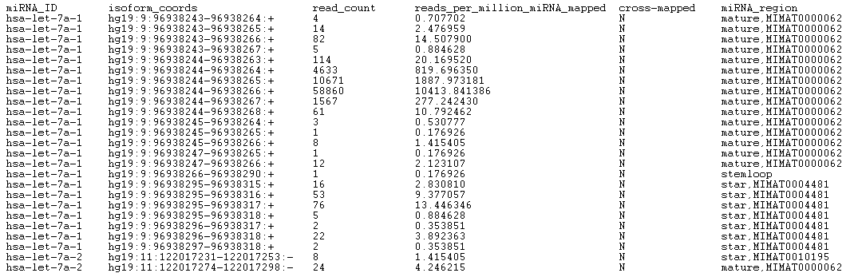

BED output format: Tab separated BED file, in which the miRNA-seq Isoform quantification file is converted, with the following fields:
- chrom (retrieved from the 2. field of the TCGA miRNA-Seq file, part just after the first “:”, e.g., “9”)
- chromStart (retrieved from the 2. field of the TCGA miRNA-Seq file, part just after the second “:”, e.g.,96938243)
- chromEnd (retrieved from the 2. field of the TCGA miRNA-Seq file, part just before the third “:”, e.g., 96938264)
- strand (retrieved from the 2. field of the TCGA miRNA-Seq file, part just after the third “:”, e.g., ‘+’)
- genome_version (retrieved from the 2. field of the TCGA miRNA-Seq file, part just before the first “:”, e.g., “hg19”)
- mirna_id (retrieved from the 1. field of the TCGA miRNA-Seq file, e.g., “has-let-7a-1”)
- read_count (retrieved from the 3. field of the TCGA miRNA-Seq file, e.g., 4)
- reads_per_million_miRNA_mapped (retrieved from the 4. field of the TCGA miRNA-Seq file, e.g., 0.707702)
- cross-mapped (retrieved from the 5. field of the TCGA miRNA-Seq file, e.g., ‘N’)
- miRNA_region (retrieved from the 6. field of the TCGA miRNA-Seq file, e.g., “mature, MIMAT0000062”)
- entrez_gene_id (retrieved from HUGO Gene Nomenclature Committee (HGNC) starting from the mirna_id provided in field 6)
- gene_symbol (retrieved from HUGO Gene Nomenclature Committee (HGNC)Error: Reference source not found starting from the mirna_id provided in field 6)

Copy Number Variation

A copy number variation (CNV) is the number of copies of a given gene per cell.
More details are available at https://wiki.nci.nih.gov/display/TCGA/SNP+array-based+data.

Two files are provided by TCGA for each aliquot:
- hg19.seg (includes both germline and somatic CNVs)
- nocnv_hg19.seg (includes only somatic CNVs)

Input:
Two tab delimited files are provided by TCGA for each aliquot, with the following fields:
- Sample (i.e., the TCGA internal sample ID)
- Chromosome (i.e., the name or number of the chromosome where the CNV is located)
- Start (i.e., the starting position of the CNV feature in the chromosome)
- End (i.e., the ending position of the CNV feature in the chromosome)
- Num_Probes (i.e., the number of consecutive probes that comprise the genome segment with the CNV)
- Segment_Mean (i.e., the estimated Copy Number (CN) ratio for the segment, that is the log₂ ratio of the tumor intensity of CN to the normal intensity of CN; use (2^{Segment_Mean}) * 2 to convert to absolute CN)

Each row in the input file refers to a single CNV.

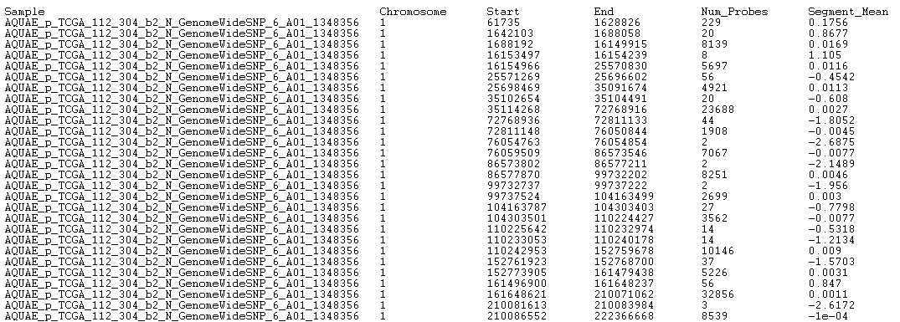

BED output format: Tab separated BED file, in which the CNV file is converted, with the following fields:
- chrom (retrieved from the 2. field of the TCGA CNV file, e.g., “1”)
- chromStart (retrieved from the 3. field of the TCGA CNV file, e.g., 61735)
- chromEnd (retrieved from the 4. field of the TCGA CNV file, e.g., 1628826)
- strand (unknown, set to ‘*’)
- Num_Probes (retrieved from the 5. field of the TCGA CNV file, e.g., 229)
- Segment_Mean (retrieved from the 6. field of the TCGA CNV file, e.g., 0.1756)
- is_nocnv (’Y’ if the current line refers to the “nocnv_hg19.seg” file, ‘N’ otherwise)

Clinical and specimen (meta) data

Meta data are data about data. Within TCGA, meta data are referred to as clinical data or specimen data. Clinical data contain several attributes related to the clinical history of the patient and of the patient’s sample. Specimen data contain attributes that concern the collection of the sample and the experimental procedure. TCGA meta data attributes are subdivided in groups which specify the type of attribute (e.g., clinical_drug, clinical_follow_up, clinical_patient, clinical_radiation, … or biospecimen_aliquot, biospecimen_analyte, biospecimen_diagnostic_slides, …).

Input:
One or more tab delimited files are provided by TCGA for all patients of a particular tumor (e.g., breast cancer), which contain several clinical, demographic, specimen attributes.
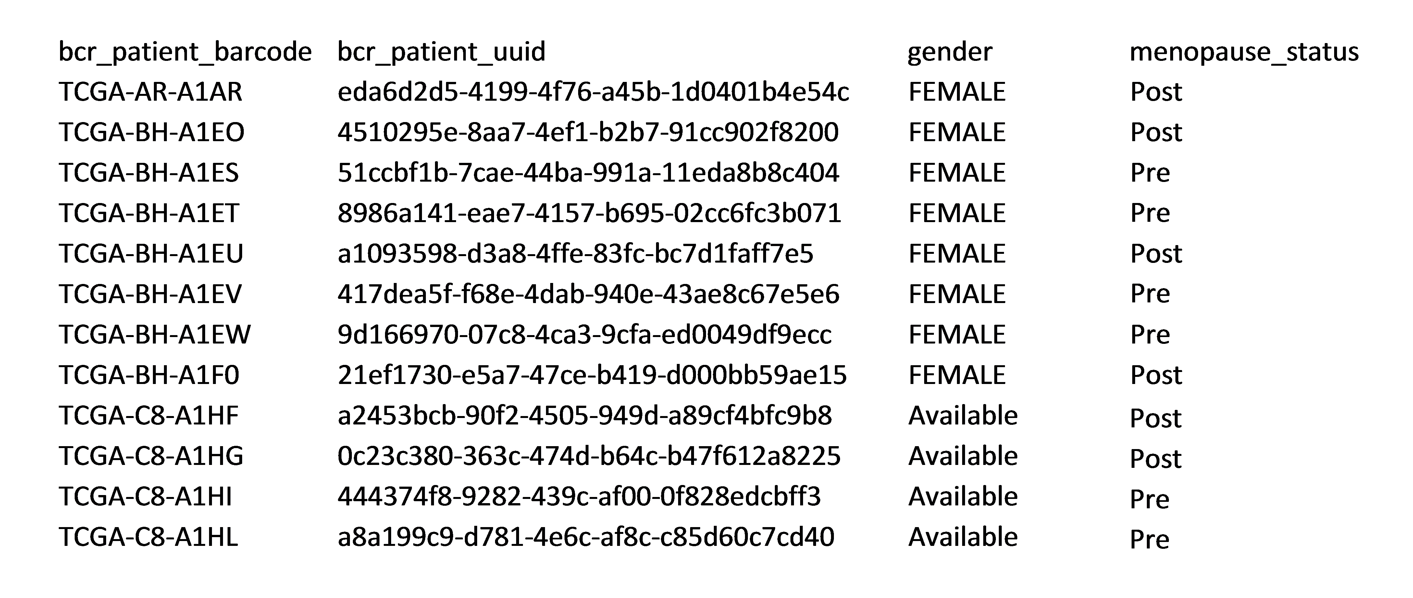

Output:
One meta data attribute tab delimited file for each patient (.meta), whose rows contain all the meta data attribute-value pairs for the specific patient, with each attribute fully specified through the pipe (|) delimited composition of the name of the group it belongs to and the name of the attribute (i.e., group_name|attribute_name, e.g., clinical_patient|tumor_tissue_site).
For example the meta data file for the patient TCGA-AR-A1AR (TCGA-AR-A1AR.meta) contains:

biospecimen_aliquot|bcr_patient_uuid eda6d2d5-4199-4f76-a45b-1d0401b4e54c
clinical_patient|gender female
clinical_patient|tumor_status tumor free
…
We added also some additional meta data attributes, within a specific group named manually_curated, and their values retrieved from the directory structure, filenames, etc. of TCGA; the main ones are the following:
- id tcga-07-0227-20a-01d-a39x-05
- dataType RNASeq
- exp_data_bed_url ftp://bioinf.iasi.cnr.it/bed/prad/cnv/TCGA-2A-A8VL-01A-21D-A376-01.bed
- exp_metadata_url ftp://bioinf.iasi.cnr.it/bed/prad/cnv/TCGA-2A-A8VL-01A-21D-A376-01.bed.meta
- md5sum ad3fdd0de6887559604a95014984a12d
- rna_seq_data_unit RPKM | RSEM | ...
- rna_seq_exp_type exon_quantification | gene_quantification | splice_junction_quantification
- seqPlatform Illumina_GA2 | Illumina_GA2e | Illumina_GA2x | Illumina_HiSeq_2000
- tissue_status tumoral | control | normal
- tumor_description Bladder Urothelial Carcinoma | ...
- tumor_tag BLCA | ...

Additional output files
We also provide the following output files:

Meta data dictionary file

One meta data dictionary tab delimited file, which contains all the possible values of any meta data attribute, for example:
menopause_status
Pre (<6 months since LMP AND no prior bilateral ovariectomy AND not on estrogen replacement)
Peri (6-12 months since last menstrual period)
[Unknown]
Post (prior bilateral ovariectomy OR >12 mo since LMP with no prior hysterectomy)
CDE_ID:2957270
histologic_diagnosis_other
Mixed infiltrating lobular and grade 1 ductal carcinoma
MUCINOUS & PAPILLARY
CDE_ID:3124492
Lobular carcinoma with ductal features
ductal/lobular
IDC+ mucinous carcinoma
Ductal/Lobular
Infiltrating ductal & lobular
Infiltrating ductal and lobular carcinoma
ductal and lobular
Invasive ductal and lobular carcinoma
lobular/ductal
Mixed invasive ductal and invasive lobular
Lobular/Ductal
[Not Applicable]
Mixed diagnosis
with ductal and lobular phenotypes
invasive ductal and lobular carcinoma

When performing batch conversions, a meta data dictionary file is generated for
- all the converted data;
- each experiment, i.e., DNA-Seq, DNA methylation, RNA-seq (V1 and V2), miRNA-seq, and CNV;
- each tumor.

Meta data information files

We output a comma separated values (CSV) file containing the occurrences of all the meta data attributes related to each tumor type (“meta2disease_table.csv”).

Additionally, we generate the following additional output files for each tumor:
- a CSV file containing the occurrence counts of each meta data attribute related to the tumor (“meta2dataType_table.csv”)
- a CSV file containing a table with a list of all meta data attributes concatenated with all possible values on the rows and the list of all available data types for the considered tumor; a generic cell of this table contains the occurrences of the pair attribute|value in a specific data type (“meta_values2dataTypes_table.csv”)
- a tab separated values (TSV) file containing a list of all meta data attributes concatenated with all possible values followed by the occurrences of this pair (attribute|value) in all data types for the considered tumor (“meta_values2sample_list.tsv”)

Experiment information files

We generate an additional output file for each subtype of all the DNA-seq, DNA methylation, RNA-seq (V1 and V2), miRNA-seq, and CNV data types, called “exp_info.tsv”. It is a tab delimited files that includes:
- number of aliquots;
- number of samples (tissue);
- number of patients.

Annotations files

We provide an additional output file for each subtype of RNA-seq (V1 and V2) experiments, called “annotations.tsv”. It is a tab delimited file that contains the following fields for each gene in the considered genomic experiment:
- gene symbol;
- entrez gene id;
- lists of gene transcript ids (only for the gene data subtype).
It is worth noting that each subtype has the same annotations.

Additional data file formats
Besides the BED format, to ensure maximum usage, we also support the set of additional data file formats following specified.

CSV format

The standard Comma Separated Values (CSV) file format defines the structure and content of the experimental data files as equal to the ones of the BED format, but a comma (instead of a tabulator) is used to separate the different fields.
The structure of the meta data files is the same as for the BED format.

XML format

The standard eXtended Markup Language (XML) file format defines the content of the experimental data files as equal to the one of the BED format, but the file structure is designed according to the XML style. In particular, we define one experimental XML file for each aliquot; the content of this file starts with the XML heading line
<?xml version="1.0" encoding="UTF-8"?>
and with the root node called <aliquot>.
Then, for each experimental measure (row of the input TCGA data file) we define a <data> tag containing the experimental fields as sub-tags and their values.
In the following, we provide an example of XML file of DNA methylation:
<?xml version="1.0" encoding="UTF-8"?>
<aliquot>
<data>
<chr>chr17</chr>
<start>62503072</start>
<stop>62503072</stop>
<strand>+</strand>
<composite_element_ref>cg00003784</composite_element_ref>
<beta_value>0.0286291327274318</beta_value>
<gene_symbol>CEP95</gene_symbol>
</data>
<data>
<chr>chr19</chr>
<start>17336525</start>
<stop>17336525</stop>
<strand>+</strand>
<composite_element_ref>cg00003818</composite_element_ref>
<beta_value>null</beta_value>
<gene_symbol>OCEL1</gene_symbol>
</data>
…
</aliquot>
The structure of the meta data files is the same as for the BED format.

JSON format

The standard JavaScript Object Notation (JSON) format defines the content of the experimental data files as equal to the one of the BED format, but the file structure is designed according to the JSON style. In particular, we define one experimental JSON file for each aliquot; the content of this file starts with the root node called “aliquot”.
Then, for each experimental measure (row of the input TCGA data file) we define a “data” tag containing the experimental fields as sub-tags and their values.
In the following, we provide an example of JSON file of DNA methylation:
{
"aliquot": {
"data": [
{
"chr": "chr17",
"start": "62503072",
"stop": "62503072",
"strand": "+",
"composite_element_ref": "cg00003784",
"beta_value": "0.0286291327274318",
"gene_symbol": "CEP95"
},
{
"chr": "chr19",
"start": "17336525",
"stop": "17336525",
"strand": "+",
"composite_element_ref": "cg00003818",
"beta_value": "null",
"gene_symbol": "OCEL1"
},
….
}
The structure of the meta data files is the same as for the BED format.

GTF format

The bioinformatics standard Gene Transfer Format (GTF) defines the content of the experimental data files as equal to the one of the BED format, but the file structure is designed according to the GTF style. In particular, we define one experimental GTF file for each aliquot.
The nine tab-separated GTF fields are:
- seqname - the name of the sequence; it must be a chromosome or scaffold (in our case, the chromosome).
- source - the program that generated this feature (in our case, TCGA2BED)
- feature - the name of this type of feature; some examples of standard feature types are "CDS", "start_codon", "stop_codon", and "exon" (in our case, “TCGA_Region”).
- start - the starting position of the feature in the sequence; the first base is numbered 1.
- end - the ending position of the feature in the sequence (inclusive).
- score - a score between 0 and 1000. In UCSC Genome Browser, if the track line useScore attribute is set to 1 for this annotation data set, the score value determines the level of gray in which this feature is displayed (higher numbers = darker gray). If there is no score value, "." is entered.
- strand - valid entries include '+', '-', or '.' (for don't know/don't care).
- frame - if the feature is a coding exon, frame should be a number between 0 and 2 that represents the reading frame of the first base; if the feature is not a coding exon, the value should be '.'.
- group - a list of attributes; each attribute consists of a type/value pair (in our case, we include the fields of the experimental data file and their values, e.g., composite_element_ref "cg00003784"; beta_value "0.0286291327274318"; gene_symbol "CEP95"). Attributes must end in a semi-colon and be separated from any following attribute by exactly one space.
In the following, we provide an example of GTF file of DNA methylation:

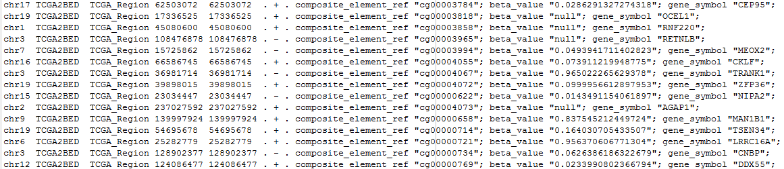

The structure of the meta data files is the same as for the BED format.

All the NCBI queries are performed according to the following rest query and by taking into account the GRCh37 (hg19) reference genome: http://eutils.ncbi.nlm.nih.gov/entrez/eutils/efetch.fcgi/?db=Gene&id=ID
Queries to HUGO Gene Nomenclature Committee (HGNC):are performed according to the following rest query http://rest.genenames.org/fetch/symbol/ followed by gene symbol, e.g., http://rest.genenames.org/fetch/symbol/BRCA1
https://www.biostars.org/p/106127/
All the NCBI queries are performed according to the following rest query and by taking into account the GRCh37 (hg19) reference genome: http://eutils.ncbi.nlm.nih.gov/entrez/eutils/efetch.fcgi/?db=Gene&id=ID
https://www.biostars.org/p/106127/
All the NCBI queries are performed according to the following rest query and by taking into account the GRCh37 (hg19) reference genome: http://eutils.ncbi.nlm.nih.gov/entrez/eutils/efetch.fcgi/?db=Gene&id=ID
Used data from the University of California at Santa Clara (UCSC) Genome Browser database are retrieved from http://hgdownload.cse.ucsc.edu/goldenPath/hg19/database/knownGene.txt.gz
Used hg19 data are retrieved from the version 20 of the miRBase database at ftp://mirbase.org/pub/mirbase/20/
Queries to HUGO Gene Nomenclature Committee (HGNC) are performed according to the following rest query http://rest.genenames.org/fetch/hgnc_id/ followed by the hgnc_id; the hgnc_id is also retrieved from HUGO starting from the mirna_id provided in field 1 of the input file
Queries to HUGO Gene Nomenclature Committee (HGNC) are performed according to the following rest query http://rest.genenames.org/fetch/hgnc_id/ followed by the hgnc_id; the hgnc_id is also retrieved from HUGO starting from the mirna_id provided in field 1 of the input file
https://www.biostars.org/p/112310/
https://genome.ucsc.edu/FAQ/FAQformat#format4

